One Token, Multiple Blockchain at Sync.

**INTRODUCTION:**

Right now the current close nature of blockchains are like the close nature of banks during the digital finance revolution, were a money in one bank at a particular location if needed to exchange customer money digitally , would needed to be exchanged by a trusted Centralized 3rd party . Same is the state of blockchains right now, where the current implementation are based off , centralized , federated or trustless options , each of them having their trade off . But defining a decentralized distributed Token mechanism , where a user’s token value ( let’s say of 1.2 Tokens ) can exist in all other blockchains , like Solana , Ethereum , BNB chain and other’s . This means that the 1.2 Token of the user will exist on all these blockchain and the user can use them whenever the user wants too .

As an analogy to explain this proposal , imagine bank A, B and C , these banks are in different countries respectively , and would like the users of Bank A use services of Bank B , same with Bank C, what if there was a special account in which the User of any Bank ,(let’s say bank A) could deposit $100 amount, and that amount would be synced in Bank B and Bank C ( digitally off course ) . This way the user can use Bank B services if the user either finds himself in the country of bank B or wants to use bank B services remotely ,same for users of Bank A and Bank C. If the user does a transaction of $10 in bank B , the protocol will make sure to update the balance of $90 in the 2 banks . If we now replace banks with Blockchains and accounts with token smart contracts , you could see how this syncing multi chain protocol can help users of a blockchain interact with other blockchains services .

Below I have discussed a potential ways to achieve this …

**Terminologies:**

**ICP ( Internet Computer )** : The Internet Computer is a blockchain hosted on node machines operated by independent parties and located in geographically distributed datacenters. The nodes run the Internet Computer Protocol, an advanced cryptographic fault-tolerant protocol which ensures that smart contracts running on the blockchain cannot be tampered with or stopped. The Internet Computer is composed of individual subnet blockchains running in parallel and connected using chain key cryptography. This means that canisters running on a subnet can seamlessly call canisters hosted in any other subnet of the Internet Computer blockchain.

**Smart Canisters :** A Canister is a super powered Smart Contract that does many more things, they are computational units that consist of both code and data. A canister can be deployed on the Internet Computer and accessed over the internet. In the technical language, it’s the state, the storage, the memory for IC applications. For easier visualization,

Bridges: a connection that allows the transfer of tokens and/or arbitrary data from one chain to another

**Notary scheme**: Notary scheme is to introduce a trusted witness to manage  
the contract ownership or ratification among untrusted parties. A notary is a trusted individual or a group of  
individuals who can manage multiple chains, initiating transactions in a chain upon the occurrence of valid  
events or requests (e.g., via deployed smart contracts) [ 13]. The notary is used to claim to one chain  
that information in another chain is valid by monitoring newly submitted activities and checking their validity [ Definition gotten from Exploring Blockchains Interoperability- A Survey paper]

Potential Solution :

1. A Notary Scheme with a Trustless third party Model : Current Notary Scheme with other Cross Chain protocols are

1 . Centralised

2 . Federated

(i.e owned by a group of individual)

3. Fully Decentalised Notary Scheme

This is where Smart Canisters of ICP can come in . Smart Canister can do HTTP outcalls in the smart canister/contract itself without a Oracle [ You can refer to this if you wanna see how it works , <https://wiki.internetcomputer.org/wiki/HTTPS_outcalls>]. Plus with Each Smart Canister able to have 8GB of storage , it makes it really ideal for this use case .

So this is how the One coin , Multiple Blockchain in Sync will work out .

1. Imagine you have Blockchains A , B and C . These blockchains all have token smart contract capability ,plus each blockchain has different TPS , finality time and block size to take into consideration .
2. Implement a Token contract with the Token symbol T , on blockchain A , B and C . The token contract should also give a special access to a specific address, which can update the token value of a specific address
3. Get the JSON RPC endpoint from respective node providers

of these token contracts when deployed .

1. Using ICP’s smart canister , you can listen for token transfers using its JSON-RPC endpoint , then sync the values across the other Blockchains ( which are A,B and C) .
2. The smart canister will then sign the transaction of update new values of the token in various other chain apart from the source chain , it will be able to sign in a secure and decentralized manner using Chain-key Cryptography [https://medium.com/dfinity/chain-key-technology-one-public-key-for-the-internet-computer-6a3644901e28]

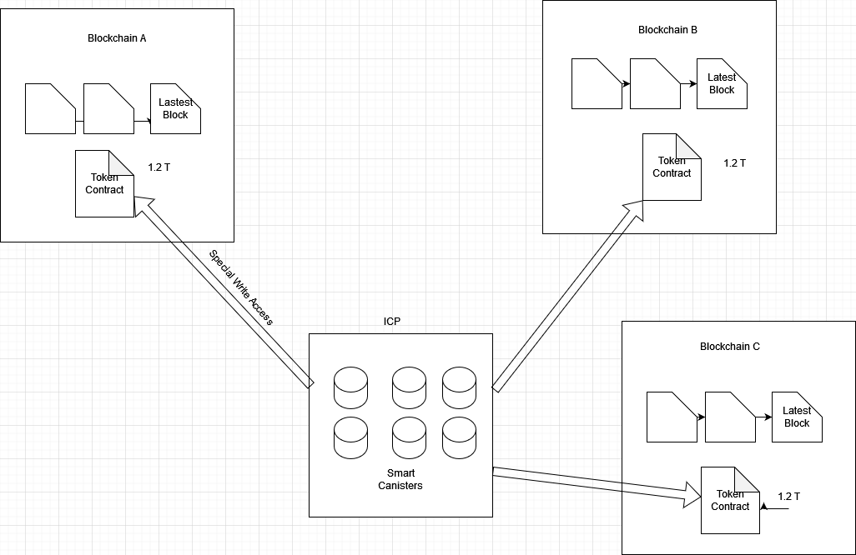

There are still some questions yet to be answered in this protocol like how will user wallet addresses work ? , how will gas fees be paid ? . Well currently it will be a user based model , where the user will provide the wallet addresses of the various blockchains , and he will pay the gas fees of the supported blockchain (in this case A,B and Blockchain C ) .Other ideas can still emerge to solve.

**How is this Model Decentralised ?**

Smart canisters are smart contracts but with a lot of space and http calls capability , hence making a single point of failure not possible

**How is this model Trust less?**

Because its made on top of the ICP blockchain , hence the 3rd party itself is a permissionless blockchain and hence can be regarded a trust less

Some interesting Works on Multi Chain Transaction in ICP https://internetcomputer.org/capabilities/multi-chain-transactions